University of Dayton

ECE

Mumma Radar Lab

Comprehensive VHDL

Fall 2016

Homework 1

Frequencies Generator

Use 100 MHz input clock, generate the following frequencies:

1. 5 MHz with 50 % duty cycle
2. 5 MHz with 75 % duty cycle
3. 5 MHz with 25 % duty cycle
4. 10 MHz with 50 % duty cycle

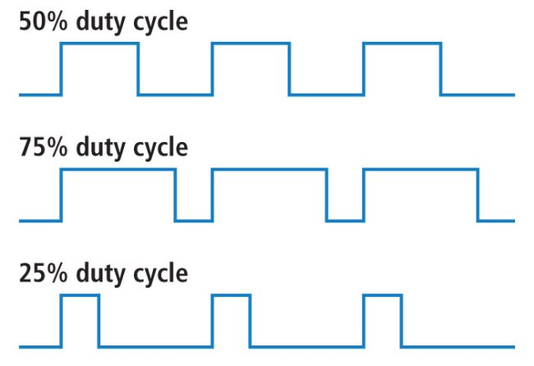

The user should be able to select between the 4 frequencies at any time.

Your entity should look like:

